LAB PROGRAM 1. Pooja k .1BM19CS111

Consider the Insurance database given below. The primary keys are underlined and the data types are specified.

PERSON (driver-id #: String, name: String, address: String)

CAR (Regno: String, model: String, year: int)

ACCIDENT (report-number: int, date: date, location: String)

OWNS (driver-id #: String, Regno: String)

PARTICIPATED (driver-id: String, Regno: String, report-number: int, damage-amount: int)

I) Create the above tables by properly specifying the primary keys and the foreign keys.

ii) Enter at least five tuples for each relation.

Sol.

I)

create table person(Driver_id varchar(10),Name varchar(15),Address varchar(20),primary key(Driver_id));

create table car(Regno varchar(10),Model varchar(15),Year int,primary key(Regno));

create table accident(Report_number int,Acc_date date,Location varchar(10),primary key(Report_number));

create table owns(Driver_id varchar(10),Regno varchar(10),primary key(Driver_id,regno),foreign key(Driver_id) references person(Driver_id),foreign key(Regno) references car(Regno));

create table participated(Driver_id varchar(10),Regno varchar(10),Report_number int,Damage_amount int,primary key(Driver_id,Regno,Report_number),foreign key(Driver_id) references person(Driver_id),foreign key(Regno) references car(Regno),foreign key(Report_number) references accident(Report_number));

ii)

insert into person(Driver_id,Name,Address)

values

('101265', 'PRASHANT', '#1,5TH CROSS,MADIWALA'),

('102233', 'ANAND', '#22,11TH CROSS,KORAMANGALA'),

('108934', 'VINAY', '#23,9TH CROSS,JAYNAGAR'),

('122563', 'JAY', '#34,7TH CROSS MADIWALA'),

('134785', 'HARSH', '#23,5TH CROSS,KORAMANGALA');

INSERT INTO car (Regno, Model, Year)

VALUES

('KA02AB1212', 'SUZUKI', 2001),

('KA05MA7634', 'RENAULT KWID', 2013),

('KA10BA1276', 'TATA ALTROZ', 2010),

('KA16AMN125', 'MAHINDRA SCORPIO', 2007),

('KA17AD4523', 'HYUNDAI I20', 2003);

insert into accident(Report_number,Acc_date,Location)

values

(4355622, '2008-04-20', 'Jayanagar'),

(6572356, '2007-07-23', 'Madiwala'),

(1234566, '2007-04-23','Madiwala'),

(2234789, '2007-09-11', 'BTM layout'),

(3456278, '2007-12-09', 'Madiwala');

INSERT INTO owns(Driver-id, Regno)

VALUES

('101265', 'KA02AB1212'),

('102233', 'KA05MA7634'),

('108934', 'KA10BA1276'),

('122563', 'KA16AMN125'),

('134785', 'KA17AD4523');

INSERT INTO participated (Driver-id, Regno, Report_number, Damage_amount)

VALUES

('101265', 'KA02AB1212', 1234566, 2000),

('102233', 'KA05MA7634', 2234789, 1250),

('108934', 'KA10BA1276', 3456278, 1000),

('122563', 'KA16AMN125', 4355622, 1500),

('134785', 'KA17AD4523', 6572356, 5000);

iii) Demonstrate how you

a. Update the damage amount for the car with a specific Regno in the accident with report number 12 to

25000.

update participated set damage_amount=25000 where report_number=1234566 and regno='KA02AB1212';

b. Add a new accident to the database.

insert into accident(Report_number,Acc_date,Location)

values(436722, '2008-04-10', 'Jayanagar');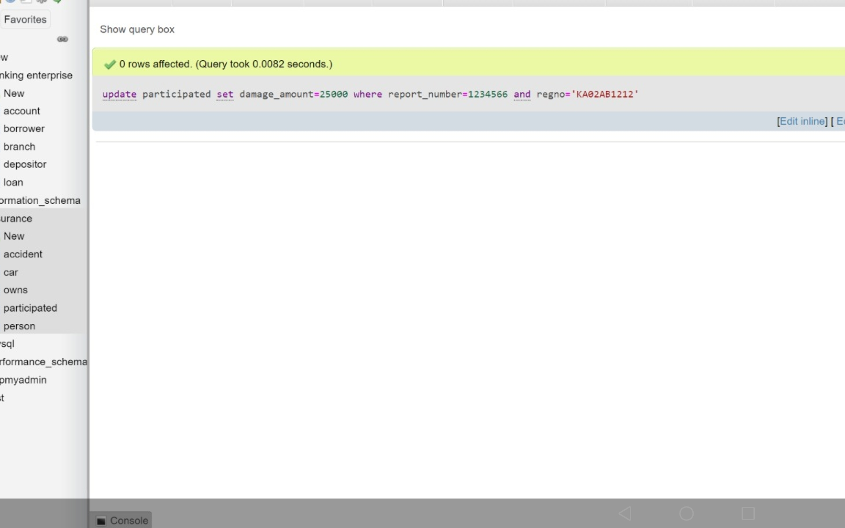

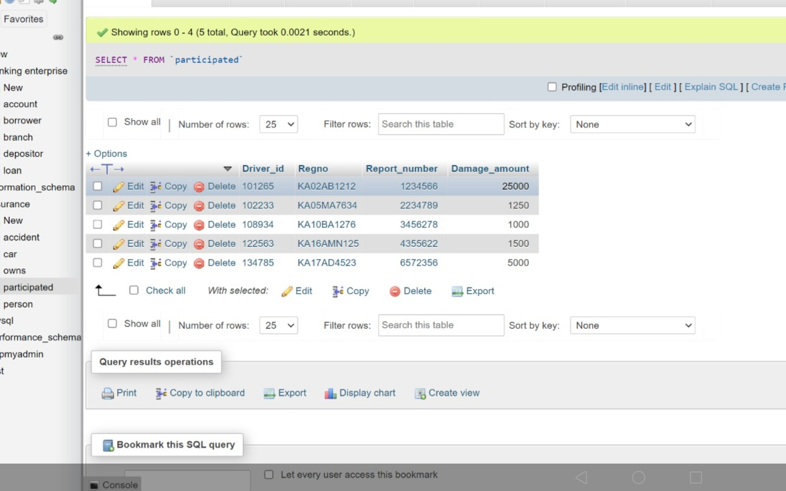

iv) Find the total number of people who owned cars that involved in accidents in 2008.

select count(distinct driver_id) CNT from participated p,accident a where p.report_number=a.report_number and a.acc_date between '2009-01-01' and '2009-12-31'

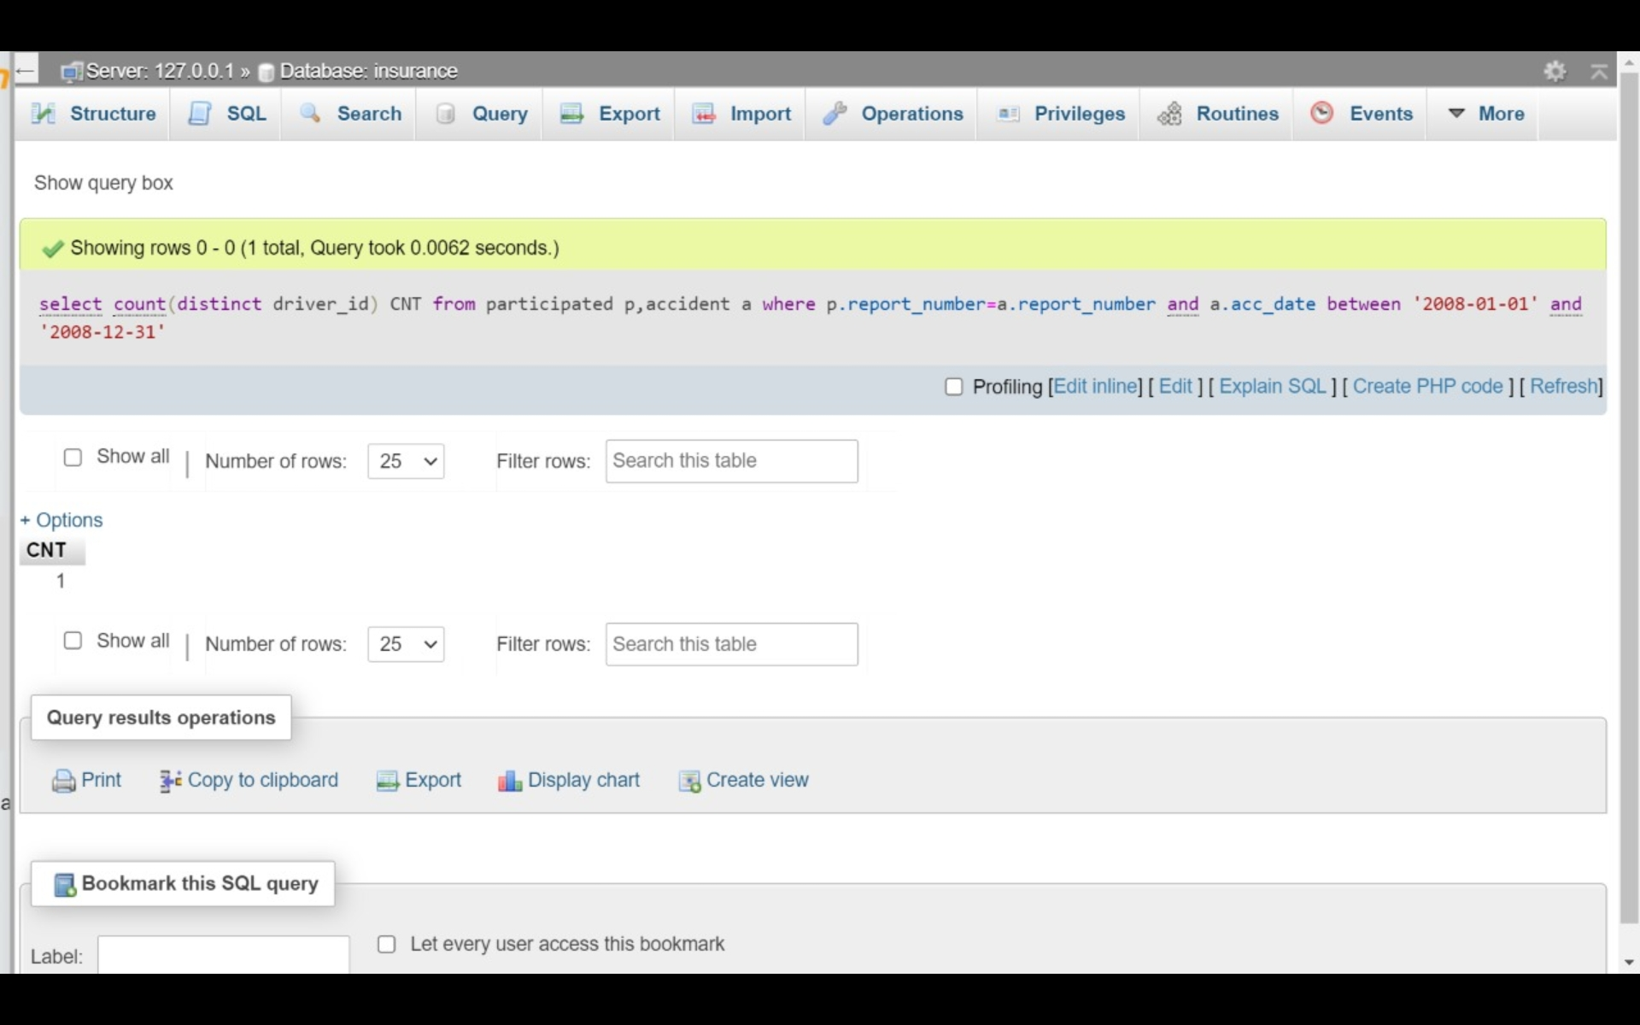

v) Find the number of accidents in which cars belonging to a specific model were involved.

select count(*) as Totalcars from car c,participated p where c.regno=p.regno and c.model='SUZUKI';

